

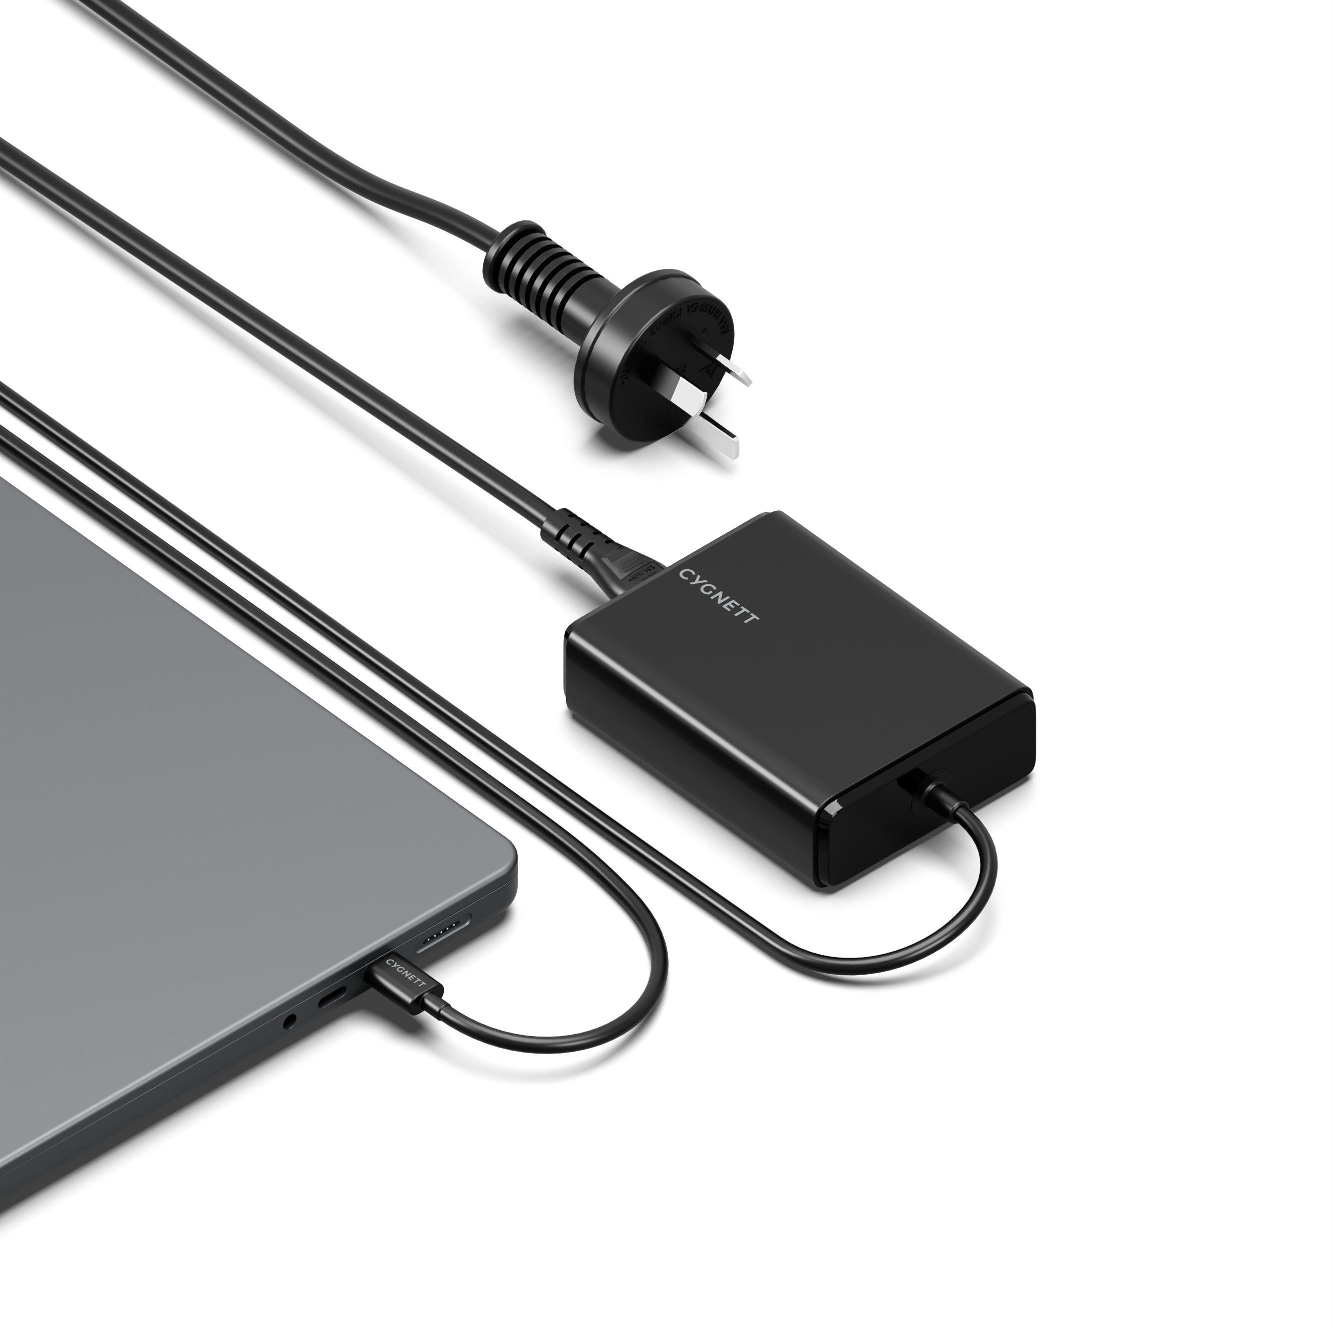

SKU: CY5072PDWCH

POWERMAXX
100W USB-C GaN LAPTOP CHARGER

Our 100W USB-C Laptop Charger delivers more than just incredible power to your laptop- it safely charges it too with robust protection against overheating and overcharging. Fast charge powerful USB-C laptops, including MacBook Pro, HP, Dell, Microsoft Surface and more.
This charger is perfect for fast charging USB-C tablets, drones, phones and other large devices that accept USB-C charging.

PRODUCT HIGHLIGHTS
PRODUCT HIGHLIGHTS

- Charge powerful laptops, phones & tablets
- 100W USB-C Power Delivery
- GaN technology
- Integrated 1M USB-C charging cable
- 2-year warranty
Charger faster and smarter with GaN
With advanced GaN technology, this charger delivers power to your laptop faster than traditional chargers. It's also more energy-efficient, reducing heat buildup and keeping your devices cooler. This not only boosts performance but also helps prevent overheating, making GaN-powered devices safer and more dependable for everyday use.

100W laptop charging
Unlock an incredible 100W USB-C PD charging power for USB-C laptops, including MacBook Pro, HP, Dell, Microsoft Surface and more. Charge with confidence knowing this laptop charger has been expert-tested and rigorously designed to meet the highest standards. Stay powered without compromising on safety.

Fast charging a wide range of USB-C devices
Charge popular USB-C devices like tablets, drones, phones that accept USB-C charging.

Integrated 1M USB-C charging cable
No additional charging cables needed, this charger comes with an integrated 1M USB-C cable that plugs directly into your laptop or other USB-C devices.

SPECIFICATIONS

INPUT:
- AC: 100-240V, 50-60Hz, 2.0A Max

USB-C OUTPUT:
- 5.0V-3.0A (15.0W)
- 9.0V-3.0A (27.0W)
- 12.0V-3.0A (36.0W)
- 15.0V-3.0A (45.0W)
- 20.0V-5.0A (100.0W)

TOTAL OUTPUT: 100.0W Max

